CHAPTER IV

RESULTS AND DISCUSSIONS

This chapter presents the research findings, including comprehensive descriptions of the physical diagram, project modules, use case, swimlane diagram, sequence diagram, Entity Relationship (ER) diagram, and flowchart. Additionally, it outlines the software and hardware requirements, as well as the results from the user acceptance testing of the mobile educational game application.

Results
The researchers employed semi-structured interviews to gather in-depth data on the learning challenges faced by Grade 4–6 students in English at San Agustin Elementary School. The findings revealed that many students struggle with vocabulary, reading comprehension, grammar, and spelling. These difficulties often stem from limited word knowledge, challenges in understanding grammar rules, problems interpreting texts, and confusion between English sounds and letters.
The study also found that traditional teaching methods, which rely heavily on rote memorization, contribute to increased anxiety and lower confidence among learners. Additionally, students frequently struggled to connect academic concepts to real-life situations, which further hindered engagement and overall learning effectiveness. These insights highlighted the need for more innovative and interactive approaches to support English learning for Grades 4–6 students at San Agustin Elementary School.
In response to these challenges, the researchers developed MagiSao, a game-based learning system designed specifically for Grades 4–6 at San Agustin Elementary School. MagiSao transforms English learning into an engaging and interactive experience by providing activities that strengthen vocabulary, reading comprehension, grammar, and spelling. Through guided learning questions, the application allows students to practice English in a fun, supportive, and accessible environment, offering immediate feedback and level progression to enhance motivation, build confidence, and reinforce understanding.

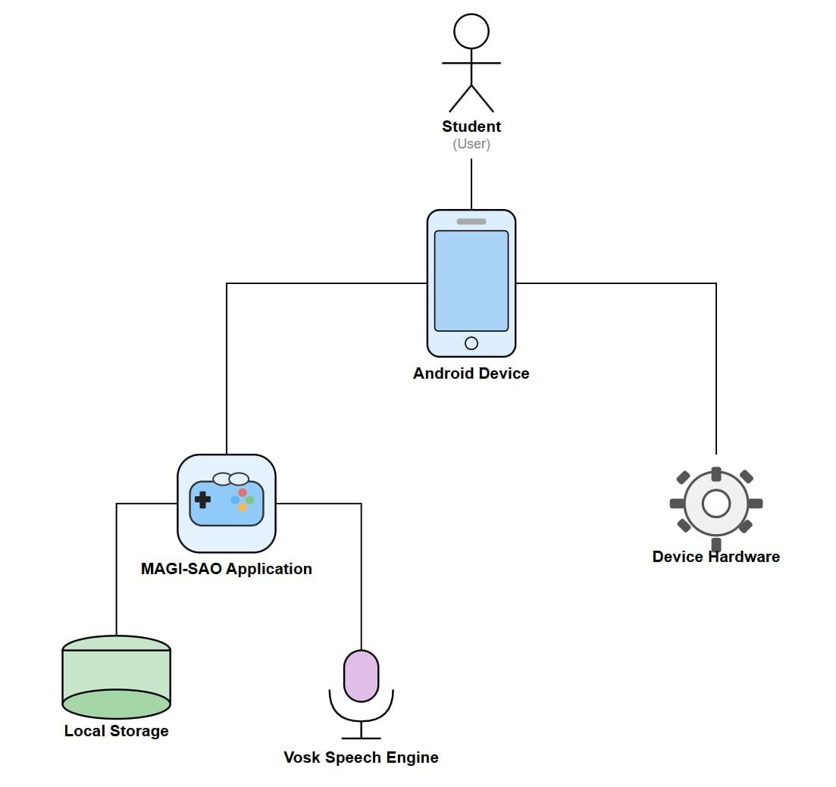
Physical Diagram of MagiSao

Figure 3: Physical Diagram of the Mobile Application
Figure 3 represents the diagram of the MagiSao mobile application designed for student users. The diagram showcases the interaction between the student and the mobile application, which is primarily facilitated through an Android device. The student interacts with the MagiSao application, which is installed on the device. The app utilizes local storage to manage data and integrates the Vosk Speech Engine for voice recognition, allowing the student to interact with the mobile application via voice commands. The device hardware, including the microphone, processes and captures the student’s speech, enabling communication between the student and the app. This diagram highlights the seamless integration of the device’s software, hardware, and external resources, ensuring smooth operation and efficient user experience for the student.

Project Module
Table 1. Project Module of the MagiSao Mobile Game Application

Module | Activity
Registration Module | Allows the students to input and save their username for identification and progression tracking.
Grade Level Module | Allows the students to choose their grade level (Grade 4, 5, or 6) based on their current educational stage. The selected grade level will determine the content and difficulty of the questions presented in the game.
Subject Module | Enables the students to choose a subject area (Spelling, Grammar, Vocabulary, and Reading) to focus on during gameplay.
Level Module | Allows the students to choose from the levels that have been unlocked in their selected category. Each subject has 20 levels, and the student can progress through the levels in sequence as they complete each one.
Answer Questions Module | Presents questions based on the selected subject and level, allowing the students to respond and receive immediate feedback on their answers.
Next Level Module | Unlocks the next level after completing the current one, providing progress tracking and motivating the user to continue
View Progress Module | Displays a summary of the user's progress, showing completed levels, accuracy, and overall performance.
View Tutorial Module | Offers instructional materials or tutorials to guide the user on how to play, navigate, and maximize the game's learning potential.
Settings Module | The student can customize their experience by toggling background music, sound effects, and vibration, adjusting volume levels, and viewing app information like version and developer details.
Exit Module | Allow the students to exit the game securely, ensuring that their progress is saved.

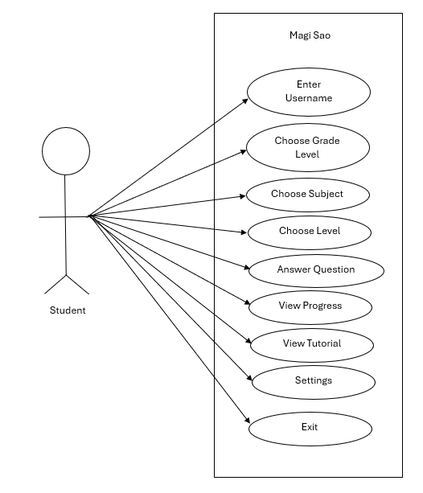
Use Case Diagram of MagiSao

Figure 4: Use Case Diagram of the Mobile Application

Figure 4 illustrates use case diagram for the Magi Sao mobile application, showing how a student interacts with the app’s features. The student is the main actor and can access various functions within the system. First, the student enters a username to identify themselves in the application. After that, the student chooses a grade level, selects a subject, and then chooses level of the game. The app then allows the student to answer questions based on their selections. In addition, the student can view their learning progress, access tutorials for guidance, adjust application settings, and exit the app when finished.
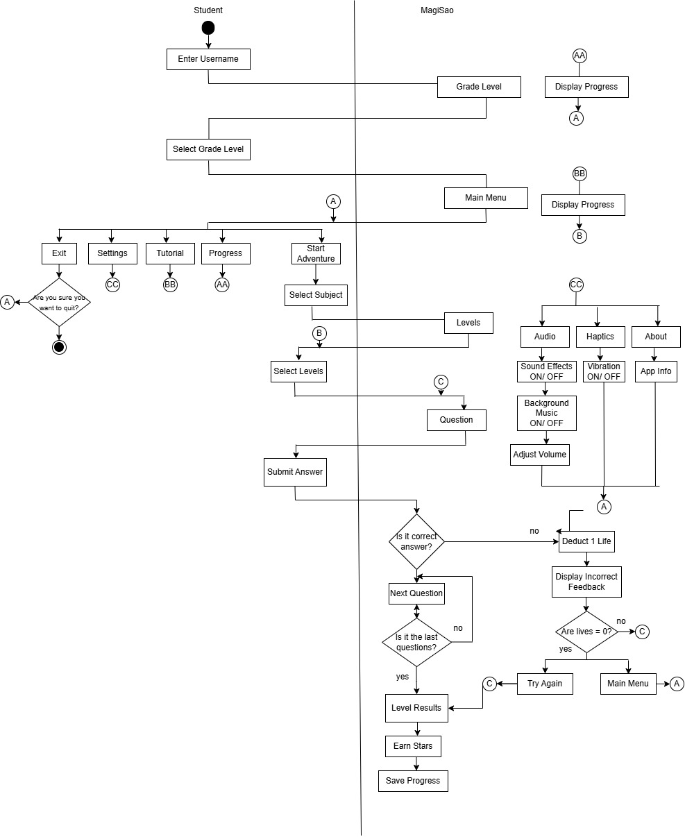
Swimlane Diagram of MagiSao
Figure 5: Swimlane Diagram of the Mobile Application
Figure 5 shows the workflow of the MagiSao educational application, showing the interaction between the Student and the mobile application. The process begins when the student enters a username and selects a grade level, after which the mobile application displays the corresponding progress and opens the main menu. From the main menu, the student can choose options such as Start Adventure, Progress, Tutorial, Settings, or Exit. In Settings, users can manage audio (sound effects, background music, and volume), haptics (vibration on/off), and view app information. When starting an adventure, the student selects a subject and level, proceeds to answer questions, and submits responses. The mobile application evaluates each answer; if correct, the student moves to the next question until the last one, where results are displayed, stars are earned, and progress is saved. If the answer is incorrect, a life is deducted, feedback is shown, and the student either retries or returns to the main menu if all lives are lost.
.

Sequence Diagram of MagiSao

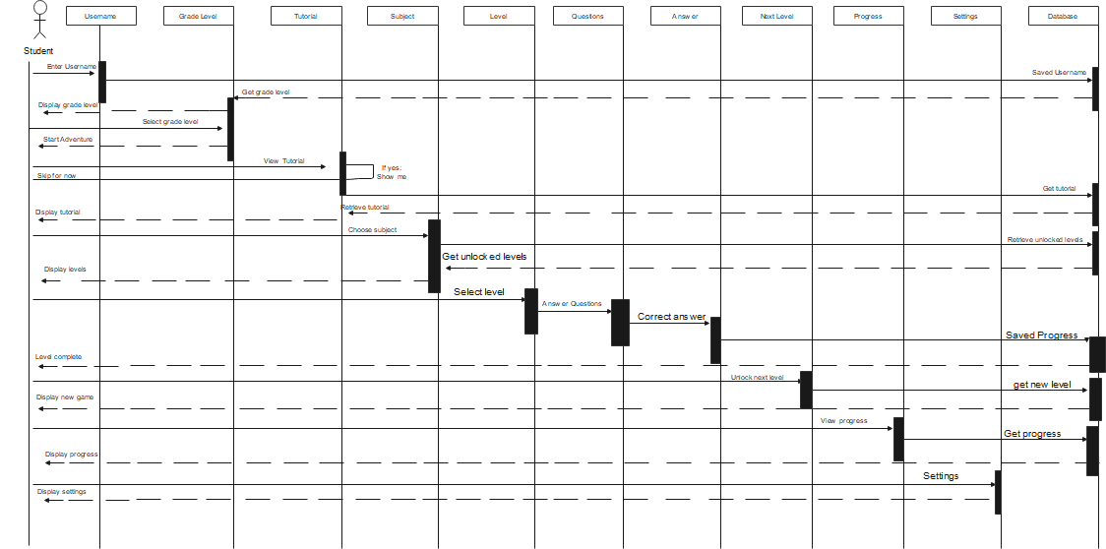

Figure 6: Sequence Diagram of the Mobile Application
Figure 6 illustrates how a student interacts step-by-step with the MagiSao mobile application and how different components of the system communicate during use. The interaction begins when the student enters a username, and the mobile applicaaaation saves it. The app then displays the grade levels, allowing the student to select one. After selecting a grade level, the student may choose to view a tutorial or skip it. If viewed, the tutorial is retrieved and displayed before continuing. Next, the student chooses a subject, and the system retrieves the unlocked levels for that subject. The student selects a level, and the questions are presented. As the student answers questions, the system checks the answers and records correct responses. Once the level is completed, the progress is saved, and the next level is unlocked. The student can then view their progress and access settings.

Flowchart Diagram of MagiSao
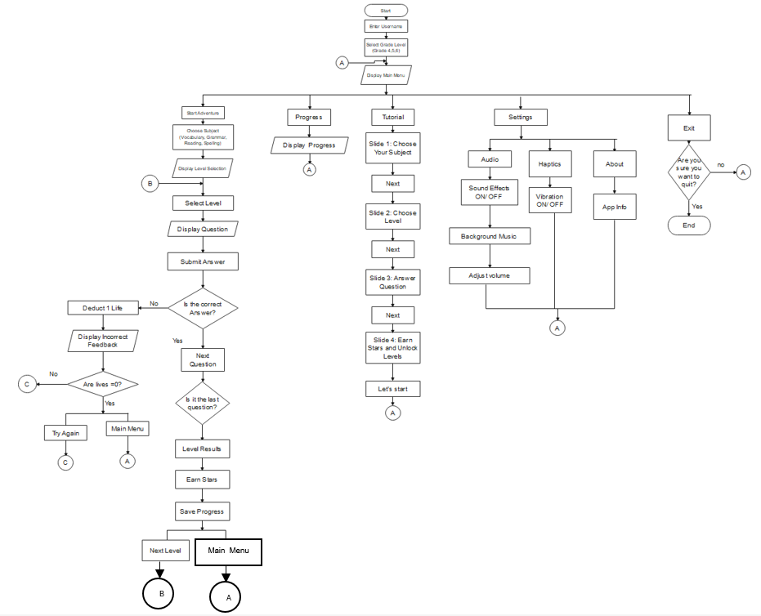

Figure 7: Flowchart Diagram of the Mobile Application
Figure 7 illustrates how students interact with the MagiSao mobile application, a structured, user-centered learning platform. The process begins when the student enters a username and selects a grade level. After the grade level is confirmed, the system directs the student to the Main Menu, where options such as Start Adventure, Display Progress, Display Tutorial, and Exit are available. When the student chooses to start the adventure, they select a subject and level, which leads to the presentation of questions. The student submits an answer, and the system evaluates whether it is correct. If the answer is correct, the student proceeds to the next question. If it is the last question, the system displays the level results, awards stars, saves progress, and allows the student to either proceed to the next level or return to the main menu. If the answer is incorrect, the system deducts a life and provides feedback. The student may try again as long as there are remaining lives; otherwise, they are redirected to retry the level or return to the main menu.

Entity Relationship Diagram of MagiSao
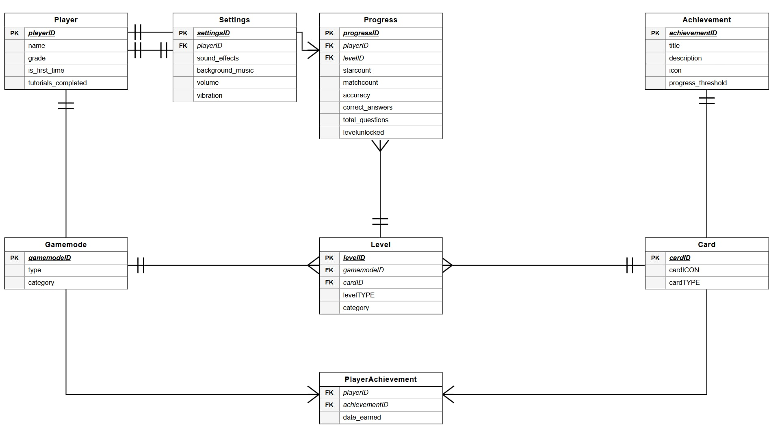
Figure 8: Entity Relationship Diagram of the Mobile Application
Figure 8 represents the database for the MagiSao application, outlining the relationships between various entities that manage user data, game settings, progress, achievements, and gameplay. The Player table contains key information about the user, including their name, grade, whether they are a first-time player, and the completion status of tutorials. This table is linked to the Settings table, which stores user preferences such as sound effects, background music, volume levels, and vibration settings. The Progress table monitors the player's in-game performance, including metrics such as match count, accuracy, correct answers, total questions, and level completion status. This table connects to the Level table, which defines the characteristics of each game level, including the level type, category, and the associated card. The Gamemode table categorizes the available game modes, while the Card table holds details about each card, such as its icon and type. The Achievement table defines the different milestones or achievements a player can earn, including a description, icon, and progress thresholds. Finally, the PlayerAchievement table links players to the achievements they have earned, along with the corresponding date. These interconnected tables ensure comprehensive tracking and management of player settings, progress, and achievements throughout the application.

Mobile Application Requirements
The researchers utilized both hardware and software components to ensure the program operated effectively. The following are the mobile application requirements that must be met for the application to run properly:
Table 2. Hardware requirements of the Mobile Application.
Hardware Requirements of the Mobile Application
Mobile Phone | Minimum Requirements
RAM | 1 GB or higher
STORAGE | 300MB + free space
CPU | ARMv7 or ARM64
GPU | OpenGL ES 3.0 support
Touchscreen | Required
Microphone | Required
Speaker | Required

Table 2 illustrates the hardware requirements for the MagiSao mobile application specify the minimum specifications needed for smooth operation on an Android device. The device must have at least 1 GB of RAM and 300 MB of free storage to ensure the application runs efficiently and stores game data. The CPU should be ARMv7 or ARM64 architecture, paired with a GPU that supports OpenGL ES 3.0 for proper graphics rendering. Essential input and output components include a touchscreen for navigation, a microphone for speech input, and a speaker for audio feedback, ensuring full functionality of the educational game features.

Table 3. Software requirements of the Mobile Application.
Software Requirements of the Mobile Application
Mobile Phone | Minimum Requirements
Operating System | Android 5.0 or higher

Table 3 outlines the software requirements for the MagiSao mobile application specify that the device must run on Android 5.0 or higher. This ensures compatibility with the application, allowing it to function smoothly and support all features, including the educational modules and interactive components.

User Acceptance Test

Acceptance testing is the process of determining whether a mobile application meets the end-user’s requirements according to predefined criteria and expected functionality. To verify the application’s reliability and usability, both alpha and beta testing were conducted.
Alpha Testing
Alpha testing is an internal process conducted by developers or quality assurance teams to identify bugs, usability issues, and functional errors before releasing the application to external users, ensuring that the core features operate as intended. In this study, alpha testing was performed on the mobile application to detect and resolve issues early in the development process. The testing was carried out by two IT professionals, Mr. Gerone Leaño and Mr. Andrew A. Acidera, who thoroughly evaluated the application’s functionality, design, and performance to ensure that the system’s core features functioned properly and met the required standards.
Table 4: Alpha Test Result
Criteria | Mean | Interpretation
Functionality
All major functions of the mobile application work as intended. | 4.50 | Agree
Navigations between menus, levels, and screen works smoothly. | 4.50 | Agree
The mobile application responds quickly to user actions. | 5.00 | Strongly Agree
The mobile application operates safely for Grade 4-6 students. | 5.00 | Strongly Agree
The mobile app loads screens and content within acceptable time. | 5.00 | Strongly Agree
Composite Mean | 4.8 | Strongly Agree
Design
The interface design is appropriate for Grade 4-6 learners. | 4.50 | Agree
Text, icons and images are clear and easy to understand. | 4.00 | Agree
The layout of screens is organized and not confusing. | 4.50 | Agree
Instructions and propmts are visible and easy to follow. | 4.00 | Agree
The overall designs makes the mobile application engaging for students. | 4.50 | Agree
Composite Mean | 4.30 | Agree
Performance
The mobile application performs well even after long period of use. | 5.00 | Strongly Agree
The mobile application runs smoothly without lag or freezing. | 4.50 | Agree
The mobile application maintains stable performance while saving or loading data. | 5.00 | Strongly Agree
Composite Mean | 4.8 | Strongly Agree

Beta Testing

Following the successful completion of alpha testing, the beta testing phase was conducted to further evaluate the mobile application with actual end users. This phase aimed to validate the application’s functionality, availability, accessibility, compatibility, security, maintainability, and reliability. The MagiSao mobile application was tested by 54 students from Grades 4 to 6 at San Agustin Elementary School to gather feedback, determine areas for enhancement, verify that the features align with user expectations, and ensure stable and dependable performance.

Table 5: Beta Test Result
Criteria | Mean | Interpretation
Functionality
The mobile application works properly while I am playing. | 4.43 | Agree
The mobile application reacts quickly when I click or choose an answer. | 4.44 | Agree
The feedback shown after each answer is accurate. | 4.46 | Agree
The levels unlock properly after completing the tasks. | 4.56 | Strongly Agree
Composite Mean | 4.47 | Agree
Availability
The mobile application adjust properly to different screen sizes (phone, tablet, etc). | 4.43 | Agree
It is easy to open and start the mobile application. | 4.59 | Strongly Agree
The mobile application still works well when many students are using. | 4.54 | Strongly Agree
Composite Mean | 4.52 | Strongly Agree
Accessibility
The mobile application content is clearly written and easy to read. | 4.39 | Agree
Text and Button in the mobile application are easy to tap. | 4.37 | Agree
Instructions are easy to understand before starting an activity. | 4.50 | Agree
Composite Mean | 4.42 | Agree
Compatibility
The mobile application is easy for students to learn and use effectively. | 4.59 | Strongly Agree
The mobile application designs is usually appealing and user friendly. | 4.57 | Strongly Agree
I can use the mobile application without needing help from an adult. | 4.41 | Agree
Composite Mean | 4.52 | Strongly Agree
Security
The mobile application does not ask for too much personal information. | 4.61 | Strongly Agree
My progress are saved safely in the application. | 4.59 | Strongly Agree
I can stop using the application anytime I want. | 4.50 | Agree
Composite Mean | 4.57 | Strongly Agree
Maintainability
The mobile application does not stop suddenly. | 4.50 | Agree
The mobile application does not have many errors. | 4.46 | Agree
The mobile application stays good even after many uses. | 4.54 | Strongly Agree
Composite Mean | 4.50 | Agree
Reliability
The mobile application does not crash while I am using it. | 4.33 | Agree
The mobile application gives correct results or answer. | 4.63 | Strongly Agree
The mobile application works well from start to finish. | 4.57 | Strongly Agree
Composite Mean | 4.51 | Strongly Agree

